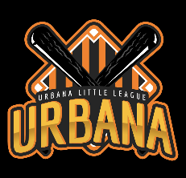 | PO BOX 17112 Urbana, IL 61803  urbanalittleleague@gmail.com
To Whom It May Concern:
Urbana Little League is a non-profit organization that is dedicated to teaching the great game of baseball to the youth of our community. We are comprised of parents of players currently playing in our league and believe in the power of youth baseball to teach life lessons, socialization, and sportsmanship that build stronger individuals and communities. One of our main goals this year is to restore the baseball fields at Yankee Ridge Elementary School. The fields at Yankee Ridge are named Jeff Kaufman Fields. They are named in honor of Jeffrey Paul Kaufman, who was a kid who loved the sport and spent many hours playing baseball on the fields with friends. Unfortunately, while in high school, he lost a long-fought battle with Hodgkins’s disease. The fields help to keep his name and spirit alive. It has been over thirty years since Jeff’s passing. The fields are no longer what they used to be. To help honor Jeff’s memory, we are raising money to restore the fields. Some of the projects included in the restoration:
- Purchase and installation of 3 new storage sheds
- Upgrading grounds around the field (grading, landscaping, drainage)
- Field restoration (cut, leveling, field dirt, weed control, etc.)
- Repair and upgrade our concession stand
- Umpire Costs and Tournament Fees
- Upgrade and repair batting cages

We will be having a silent auction on Opening Day April 20 at Jeff Kaufman Fields. We are requesting donations in the form of gift cards, merchandise, and/or monetary value that we would be able to enter in the silent auction or add to overall fundraising goal. Any support will be greatly appreciated.

Thanking you in advance for your consideration.
Sincerely,

Julie Ann Palermo
President
Urbana Little League

